**INTERNET PROGRAMMING LAB**

**Ex5**

**Profile Servlet using Session and MySQL**

**Name : Vikraman S**

**Reg No : 185001195**

**Learning Objective:**

To implement Profile Servlet using Http Sessions.

**Specifications:**

1. The login page should contain username, password, login button and logout button. On clicking login button, invoke the LoginServlet.

2. The LoginServlet should authenticate the user and store the username in session for viewing his profile and display a message “Welcome username”.

3. The LoginServlet should also display a link “View Profile in Detail”. The link when clicked, should invoke ProfileServlet.

4. ProfileServlet should display the username retrieved from the session with the message “Welcome username to the profile page”. Also retrieve and display the detail information of the user from the database in that page. It also displays a link to the Login page to logout.

5. When Logout button is pressed, invoke the LogoutServlet.

6. LogoutServlet should invalidate the user session and display “Successfully Logged out”

**Code:**

**login.html**

<!DOCTYPE html>

<html>

<head>

<meta charset=**"utf-8"**>

<meta name=**"viewport"** content=**"width=device-width, initial-scale=1.0"**>

<link rel=**"stylesheet"** href=**"style.css"**>

<title>**Login**</title>

</head>

<body>

<center><h1>**Login**</h1></center>

<form method=**"post"** action=**"http://localhost:8080/Ex5/Login"**>

<br><label for=**"uname"**>**User Name:**</label>

<input type=**"text"** id=**"uname"** name=**"uname"** placeholder=**"Enter User Name"** value=**""** required><br>

<br><label for=**"password"**>**Password :**</label>

<input type=**"password"** id=**"password"** name=**"password"** value=**""** required><br>

<br><input id=**"login"** type=**"submit"** value=**"Login"**>

</form>

</body>

</html>

**style.css**

form**{**

**margin-left: 30%;**

**font-size:17px;**

**font-family:arial;**

**font-weight:bold;**

**color:darkblue;**

**background-color:lavender;**

**padding:30px;**

**border:5px solid black;**

**border-radius: 20px;**

**width:35%;**

**box-shadow: 10px 10px 5px grey;**

**}**

input**,**select**,**textarea**{**

**font-size:17px;**

**font-family:arial;**

**padding: 12px 20px;**

**margin: 8px 0;**

**}**

input**[**type=submit**]{**

**border-radius: 8px;**

**}**

**#login{**

**width:20%;**

**font-weight: bold;**

**background-color:lightgreen;**

**position:relative;**

**left:200px;**

**}**

**#logout{**

**width:20%;**

**font-weight: bold;**

**background-color:lightblue;**

**}**

input**[**type=submit**]:hover{**

**color:blue;**

**}**

table**,**th**,**td **{**

**border: 2px solid black;**

**border-collapse: collapse;**

**padding: 10px;**

**}**

th **{**

**background-color: #65af79;**

**font-size: 23px;**

**color: blue;**

**}**

td **{**

**background-color: #656da0;**

**color: gold;**

**font-size: 20px;**

**list-style-type: none;**

**}**

table **{**

**margin-left: auto;**

**margin-right: auto;**

**text-align: center;**

**width: 50%;**

**border-radius: 20px;**

**box-shadow: 10px 10px 5px grey;**

**}**

body **{**

**background-color: #A0DAA9;**

**height: auto;**

**background-image: linear-gradient(to right,#0072B5,white,#CD212A);**

**}**

**Login.java**

**import** java**.**io**.*;**

**import** java**.**util**.*;**

**import** javax**.**servlet**.*;**

**import** javax**.**servlet**.**http**.*;**

**import** java**.**sql**.*;**

public class Login **extends** HttpServlet

**{**

public void doPost**(**HttpServletRequest request**,** HttpServletResponse response**)** **throws** ServletException**,** IOException

**{**

String JDBC_DRIVER **=** "com.mysql.jdbc.Driver"**;**

String DB_URL**=**"jdbc:mysql://localhost/profile"**;**

String USER **=** "root"**;**

String PASS **=** "9500"**;**

response**.**setContentType**(**"text/html"**);**

PrintWriter out **=** response**.**getWriter**();**

String user_name**=**request**.**getParameter**(**"uname"**);**

String pwd**=**request**.**getParameter**(**"password"**);**

**try** **{**

// Register JDBC driver

Class**.**forName**(**"com.mysql.jdbc.Driver"**);**

// Open a connection

Connection conn **=** DriverManager**.**getConnection**(**DB_URL**,** USER**,** PASS**);**

// Execute SQL query

Statement stmt **=** conn**.**createStatement**();**

String sql**=**"SELECT uname,password FROM details"**;**

ResultSet rs **=** stmt**.**executeQuery**(**sql**);**

out**.**println**(**"<!DOCTYPE html>"**+**

"<html>"**+**

"<head>"**+**

"<meta charset='utf-8'>"**+**

"<meta name='viewport' content='width=device-width, initial-scale=1.0'>"**+**

"<link rel='stylesheet' href='style.css'>"**+**

"<title>Login</title>"**+**

"</head>"**+**

"<body><center><br>"**);**

// Extract data from result set

int flag**=**0**;**

**while(**rs**.**next**())**

**{**

//Retrieve by column name

String uname**=** rs**.**getString**(**"uname"**);**

String password**=** rs**.**getString**(**"password"**);**

**if(**user_name**.**equals**(**uname**)** **&&** pwd**.**equals**(**password**))**

**{**

out**.**println**(**"<h1>Welcome "**+**user_name**+**

"<br><br><a href='http://localhost:8080/Ex5/Profile'>Click here to view the profile"**+**

"</center></body>"**+**

"</html>"**);**

HttpSession session **=** request**.**getSession**();**

session**.**setAttribute**(**"uname"**,**user_name**);**

session**.**setAttribute**(**"password"**,**pwd**);**

flag**=**1**;**

**break;**

**}**

**}**

**if(**flag**==**0**)**

**{**

out**.**println**(**"<h1>Invalid Login<br><br>Try Again"**+**

"</center>"**+**

"<script>"**+**

"setTimeout(view, 1500);"**+**

"function view()"**+**

"{window.location.replace('http://localhost:8080/Ex5/login.html');}"**+**

"</script>"**+**

"</body>"**+**

"</html>"**);**

**}**

// Clean-up environment

rs**.**close**();**

stmt**.**close**();**

conn**.**close**();**

out**.**close**();**

**}** **catch(**SQLException se**)** **{**

//Handle errors for JDBC

se**.**printStackTrace**();**

**}** **catch(**Exception e**)** **{**

//Handle errors for Class.forName

e**.**printStackTrace**();**

**}**

**}**

**}**

**Profile.java**

**import** java**.**io**.*;**

**import** java**.**util**.*;**

**import** javax**.**servlet**.*;**

**import** javax**.**servlet**.**http**.*;**

**import** java**.**sql**.*;**

public class Profile **extends** HttpServlet

**{**

public void doGet**(**HttpServletRequest request**,** HttpServletResponse response**)** **throws** ServletException**,** IOException

**{**

String JDBC_DRIVER **=** "com.mysql.jdbc.Driver"**;**

String DB_URL**=**"jdbc:mysql://localhost/profile"**;**

String USER **=** "root"**;**

String PASS **=** "9500"**;**

response**.**setContentType**(**"text/html"**);**

PrintWriter out **=** response**.**getWriter**();**

HttpSession session **=** request**.**getSession**();**

String user_name**=(**String**)**session**.**getAttribute**(**"uname"**);**

String pwd**=(**String**)**session**.**getAttribute**(**"password"**);**

**try** **{**

// Register JDBC driver

Class**.**forName**(**"com.mysql.jdbc.Driver"**);**

// Open a connection

Connection conn **=** DriverManager**.**getConnection**(**DB_URL**,** USER**,** PASS**);**

// Execute SQL query

Statement stmt **=** conn**.**createStatement**();**

String sql**=**"SELECT name,age,gender,phone FROM details WHERE uname='"**+**user_name**+**"'AND password='"**+**pwd**+**"'"**;**

ResultSet rs **=** stmt**.**executeQuery**(**sql**);**

rs**.**next**();**

String name**=** rs**.**getString**(**"name"**);**

String age**=** rs**.**getString**(**"age"**);**

String gender**=** rs**.**getString**(**"gender"**);**

String phone**=** rs**.**getString**(**"phone"**);**

out**.**println**(**"<!DOCTYPE html>"**+**

"<html>"**+**

"<head>"**+**

"<meta charset='utf-8'>"**+**

"<meta name='viewport' content='width=device-width, initial-scale=1.0'>"**+**

"<link rel='stylesheet' href='style.css'>"**+**

"<title>Profile</title>"**+**

"</head>"**+**

"<body><center><br>"**+**

"<h1>Welcome "**+**user_name**+**" to the profile page</h1><br><br>"**+**

"<table>"**+**

"<tr>"**+**

"<th>Name</th>"**+**

"<td>"**+**name**+**"</td>"**+**

"</tr>"**+**

"<tr>"**+**

"<th>Age</th>"**+**

"<td>"**+**age**+**"</td>"**+**

"</tr>"**+**

"<tr>"**+**

"<th>Gender</th>"**+**

"<td>"**+**gender**+**"</td>"**+**

"</tr>"**+**

"<tr>"**+**

"<th>Phone</th>"**+**

"<td>"**+**phone**+**"</td>"**+**

"</tr>"**+**

"</table><br><br>"**+**

"<input type='button' id='logout' value='Logout' onclick=window.location.replace('http://localhost:8080/Ex5/Logout')>"**+**

"</body>"**+**

"</html>"**);**

// Clean-up environment

rs**.**close**();**

stmt**.**close**();**

conn**.**close**();**

out**.**close**();**

**}** **catch(**SQLException se**)** **{**

//Handle errors for JDBC

se**.**printStackTrace**();**

**}** **catch(**Exception e**)** **{**

//Handle errors for Class.forName

e**.**printStackTrace**();**

**}**

**}**

**}**

**Logout.java**

**import** java**.**io**.*;**

**import** java**.**util**.*;**

**import** javax**.**servlet**.*;**

**import** javax**.**servlet**.**http**.*;**

**import** java**.**sql**.*;**

public class Logout **extends** HttpServlet

**{**

public void doGet**(**HttpServletRequest request**,** HttpServletResponse response**)** **throws** ServletException**,** IOException

**{**

response**.**setContentType**(**"text/html"**);**

PrintWriter out **=** response**.**getWriter**();**

HttpSession session **=** request**.**getSession**();**

session**.**invalidate**();**

out**.**println**(**"<!DOCTYPE html>"**+**

"<html>"**+**

"<head>"**+**

"<meta charset='utf-8'>"**+**

"<meta name='viewport' content='width=device-width, initial-scale=1.0'>"**+**

"<link rel='stylesheet' href='style.css'>"**+**

"<title>Logout</title>"**+**

"</head>"**+**

"<body><center><br>"**+**

"<h1>Successfully Loged out</h1>"**+**

"<script>"**+**

"setTimeout(view, 1500);"**+**

"function view()"**+**

"{window.location.replace('http://localhost:8080/Ex5/login.html');}"**+**

"</script>"**+**

"</body>"**+**

"</html>"**);**

**}**

**}**

**web.xml**

<web-app>

<servlet>

<servlet-name>**Login**</servlet-name>

<servlet-class>**Login**</servlet-class>

</servlet>

<servlet-mapping>

<servlet-name>**Login**</servlet-name>

<url-pattern>**/Login**</url-pattern>

</servlet-mapping>

<servlet>

<servlet-name>**Profile**</servlet-name>

<servlet-class>**Profile**</servlet-class>

</servlet>

<servlet-mapping>

<servlet-name>**Profile**</servlet-name>

<url-pattern>**/Profile**</url-pattern>

</servlet-mapping>

<servlet>

<servlet-name>**Logout**</servlet-name>

<servlet-class>**Logout**</servlet-class>

</servlet>

<servlet-mapping>

<servlet-name>**Logout**</servlet-name>

<url-pattern>**/Logout**</url-pattern>

</servlet-mapping>

</web-app>

**Screenshots:**

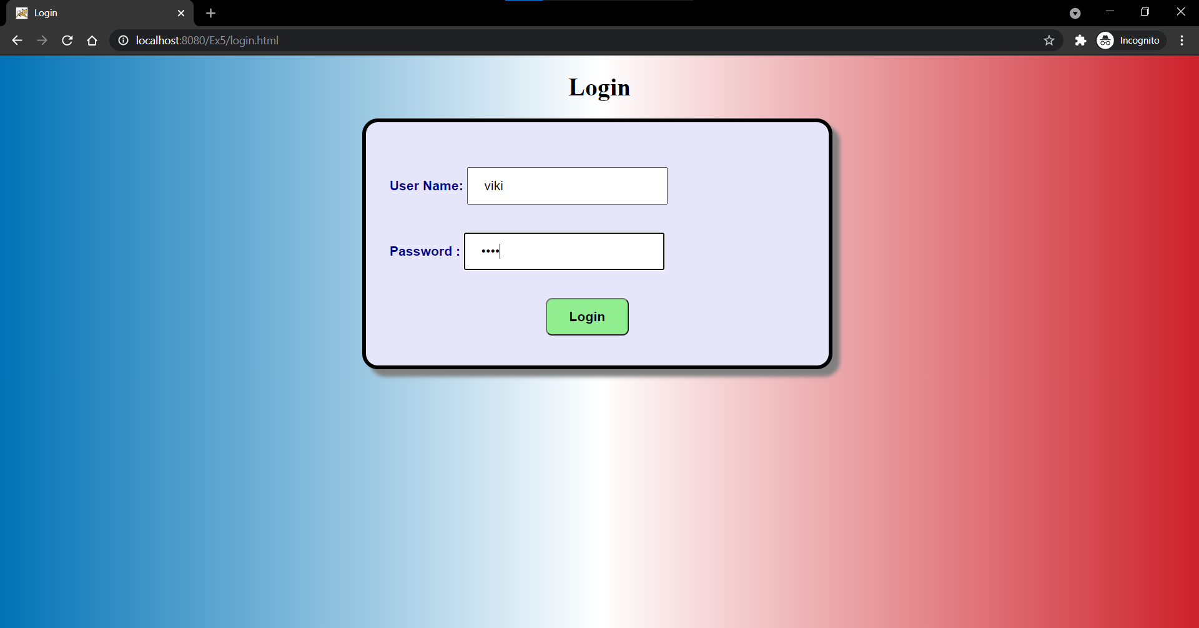

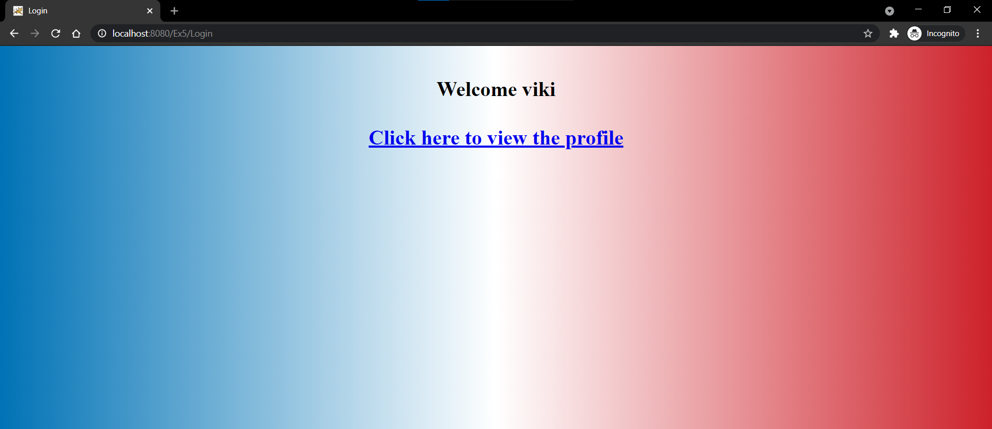

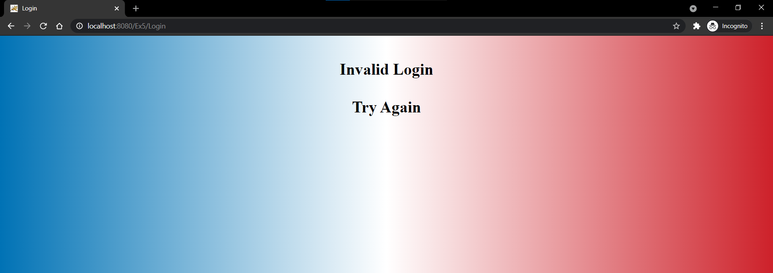

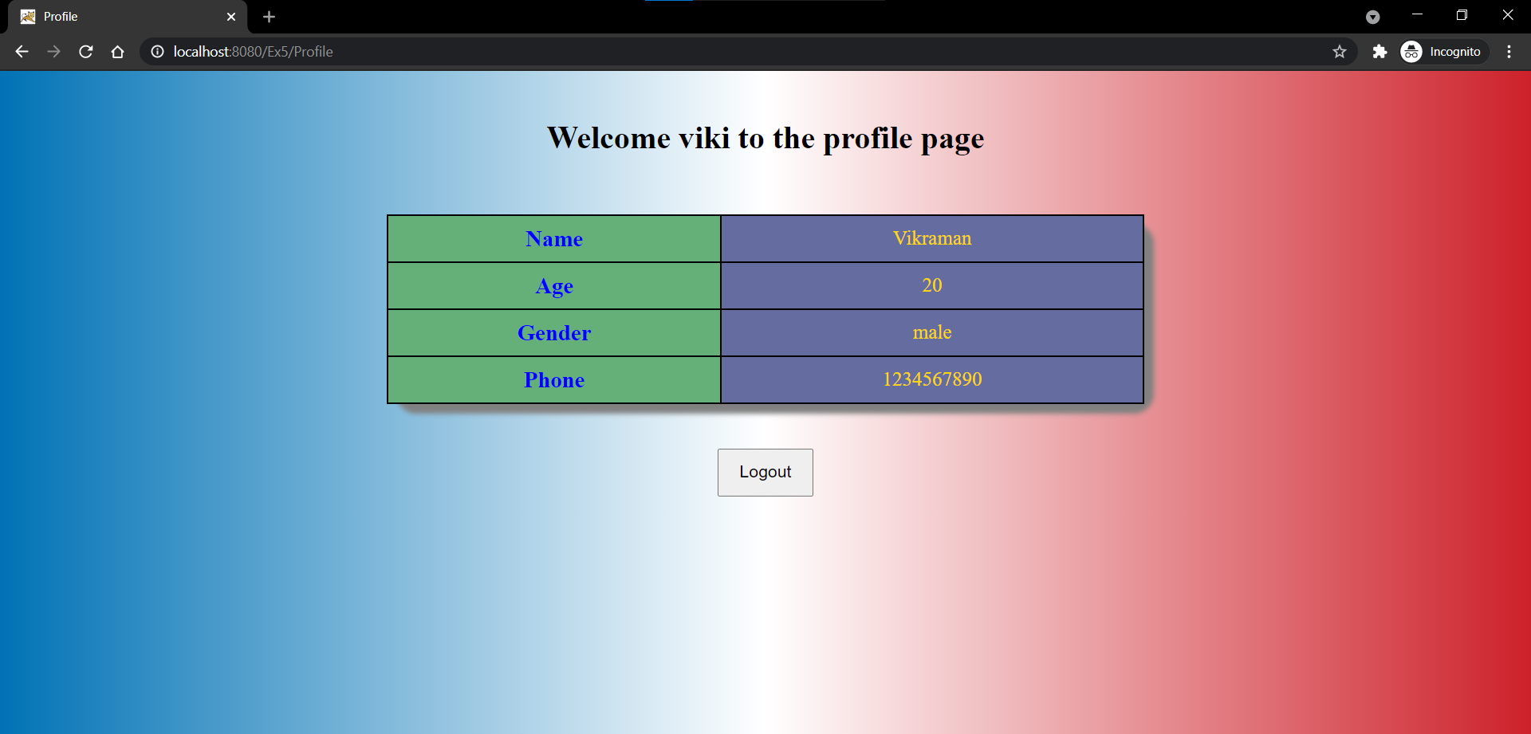

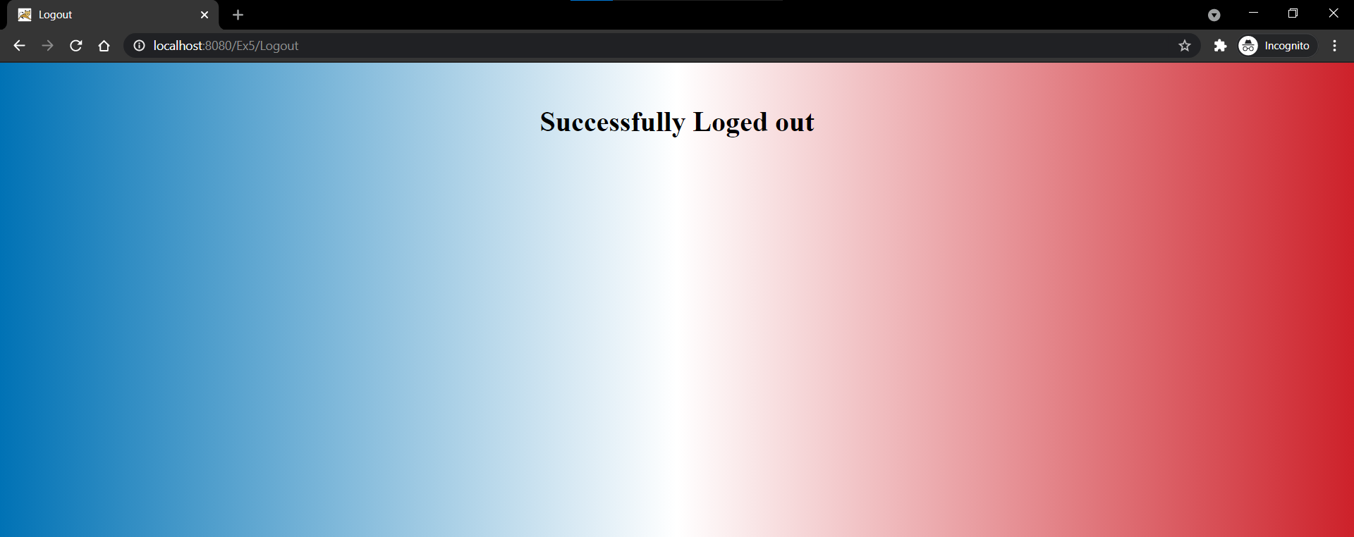

**Learning Outcomes:**

* I have understood the working of servlet and difference between GET and POST methods.
* I have learnt how to generate dynamic html response using servlet programming.
* I have learnt about Http sessions and understood session methods.
* I have learnt the database operations in MySQL and session tracking code.
* I have understood the code for connecting database and servlet part.